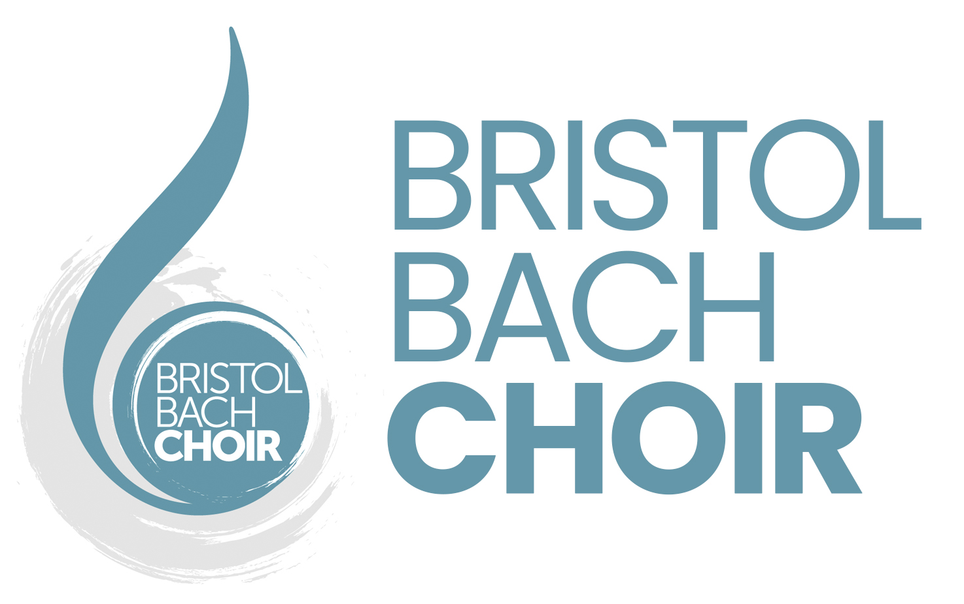
Application Form

Please complete and return by email to membership@bristolbach.org.uk

Name
Voice part
Postal address

Email address
Phone number

- Choral Experience
What previous experience, if any, do you have of singing with choirs?

- Other Musical Experience
Do you have other musical experience such as playing an instrument?

- Other Information
Why do you think the Bristol Bach Choir would be the right choir for you?

How did you hear about us?

Have you attended an open rehearsal?

If yes, what did you think of it? What feedback would you give us for forthcoming rehearsals?

